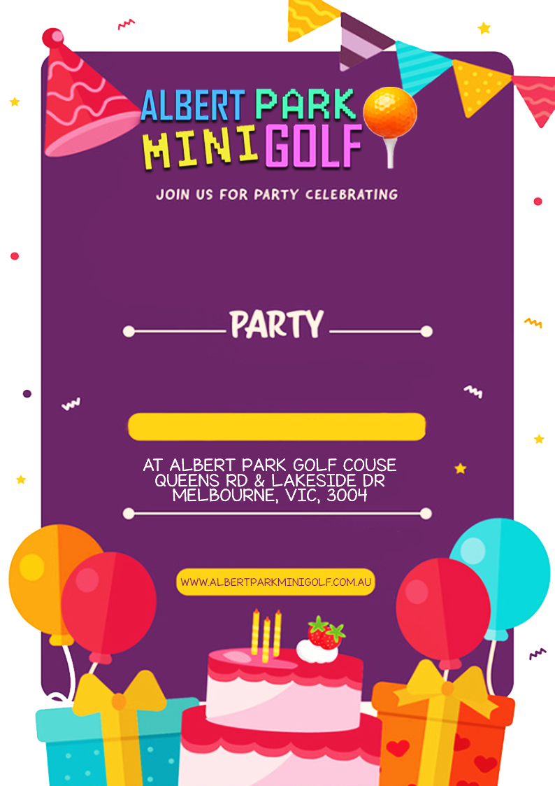­

SATURDAY 5TH DECEMBER

AT ALBERT PARK GOLF COURSE

QUEENS RD & LAKESIDE DR

MELBOURNE, VIC, 3004

**“PAID PARKING APPLIES”**



CHARLIE HOGAN

RSVP TO SAM 0423 456 789

BY OCTOBER 10TH

7th BIRTHDAY